# JDBC Driver

|  |
| --- |
| JDBC Driver is a software component that enables java application to interact with the database. There are 4 types of JDBC drivers:   1. JDBC-ODBC bridge driver 2. Native-API driver (partially java driver) 3. Network Protocol driver (fully java driver) 4. Thin driver (fully java driver) |

### 1) JDBC-ODBC bridge driver

|  |
| --- |
| The JDBC-ODBC bridge driver uses ODBC driver to connect to the database. The JDBC-ODBC bridge driver converts JDBC method calls into the ODBC function calls. This is now discouraged because of thin driver. |

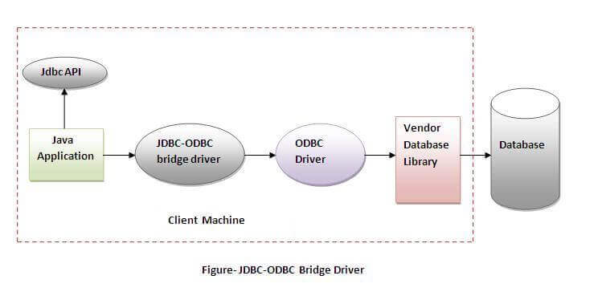

#### *In Java 8, the JDBC-ODBC Bridge has been removed.*

Oracle does not support the JDBC-ODBC Bridge from Java 8. Oracle recommends to use JDBC drivers provided by the vendor of your database instead of the JDBC-ODBC Bridge.

### Advantages:

* easy to use.
* can be easily connected to any database.

### Disadvantages:

* Performance degraded because JDBC method call is converted into the ODBC function calls.
* The ODBC driver needs to be installed on the client machine.

### 2) Native-API driver

|  |
| --- |
| The Native API driver uses the client-side libraries of the database. The driver converts JDBC method calls into native calls of the database API. It is not written entirely in java. |

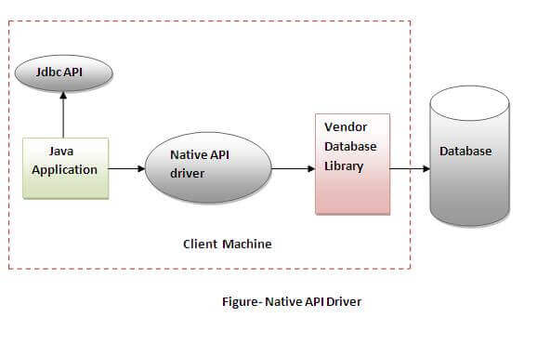

### Advantage:

* performance upgraded than JDBC-ODBC bridge driver.

### Disadvantage:

* The Native driver needs to be installed on the each client machine.
* The Vendor client library needs to be installed on client machine.

### 3) Network Protocol driver

The Network Protocol driver uses middleware (application server) that converts JDBC calls directly or indirectly into the vendor-specific database protocol. It is fully written in java.

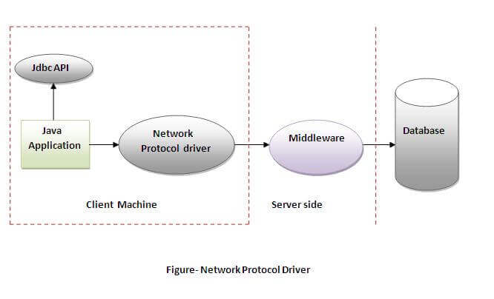

### Advantage:

* No client side library is required because of application server that can perform many tasks like auditing, load balancing, logging etc.

### Disadvantages:

* Network support is required on client machine.
* Requires database-specific coding to be done in the middle tier.
* Maintenance of Network Protocol driver becomes costly because it requires database-specific coding to be done in the middle tier.

### 4) Thin driver

|  |
| --- |
| The thin driver converts JDBC calls directly into the vendor-specific database protocol. That is why it is known as thin driver. It is fully written in Java language. |

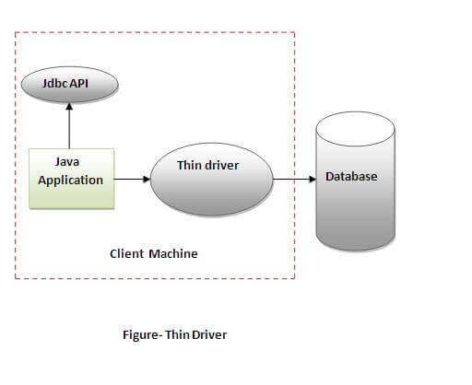

### Advantage:

* Better performance than all other drivers.
* No software is required at client side or server side.

### Disadvantage:

* Drivers depend on the Database.